Luxury Housing Sales Analysis – Bengaluru
Project: Luxury Housing Sales Analysis – Bengaluru
Tools: Python | Pandas | NumPy | Power BI | DAX
Dataset: 100,000 Rows × 23 Columns
Prepared by: Devendra p

Project Objective
To analyze Bengaluru’s luxury housing sales data and identify important market trends, buyer preferences, developer performance, and booking patterns using Python and Power BI.
Dataset
Rows: 100,000
Columns: 23
Source: Cleaned CSV file
Location: Bengaluru
Domain: Luxury Housing Sales

Python Data Cleaning
Python was used to clean and prepare the Bengaluru luxury housing dataset before importing it into Power BI.
- Removed or handled missing values
- Corrected invalid data
- Cleaned categorical values
- Checked duplicate records
- Prepared the dataset for analysis
Feature Engineering
New useful columns were created from the existing data to support deeper analysis in Power BI.
- Price_per_Sqft → Price based on unit size
- Booking_Flag → 1 = Booked, 0 = Not Booked
- Quarter_Number → Numerical quarter
- Quarter_Label → Quarter name
- Purchase_Year → Year of purchase
Final Cleaned Dataset
After data cleaning and feature engineering, the final dataset contained 100,000 rows and 23 columns. This cleaned CSV file was used directly in Power BI for analysis and dashboard creation.
Power BI Development
The cleaned CSV file was imported directly into Power BI to create an interactive dashboard for analyzing Bengaluru’s luxury housing sales.
- Imported the cleaned CSV
- Created DAX measures (Data Analysis Expressions.)
- Created KPI cards
- Added interactive filters
- Created charts and visualizations
- Built 3 dashboard pages
DAX Measures & KPIs (Key Performance Indicator.)
DAX measures were created to calculate important sales and booking metrics for the dashboard.
- Total Transactions
- Total Bookings
- Total Ticket Sales
- Average Ticket Price
- Booking Conversion Rate
Dashboard
The Power BI dashboard contains 3 interactive pages designed to analyze luxury housing sales, bookings, developers, and market performance.
Page 1 – Market Analysis
Analyzes micro-markets, sales, bookings, and demand.
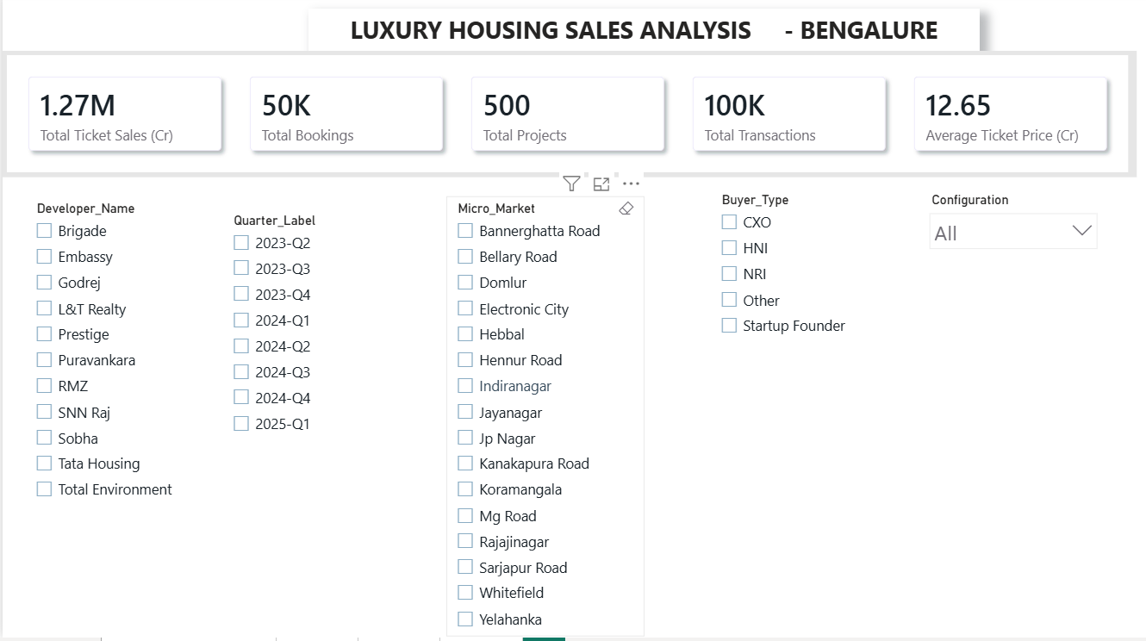
Figure 1: Power BI Dashboard – Page 1

Page 2 – Developer Analysis
Analyzes developer performance and ticket sales.
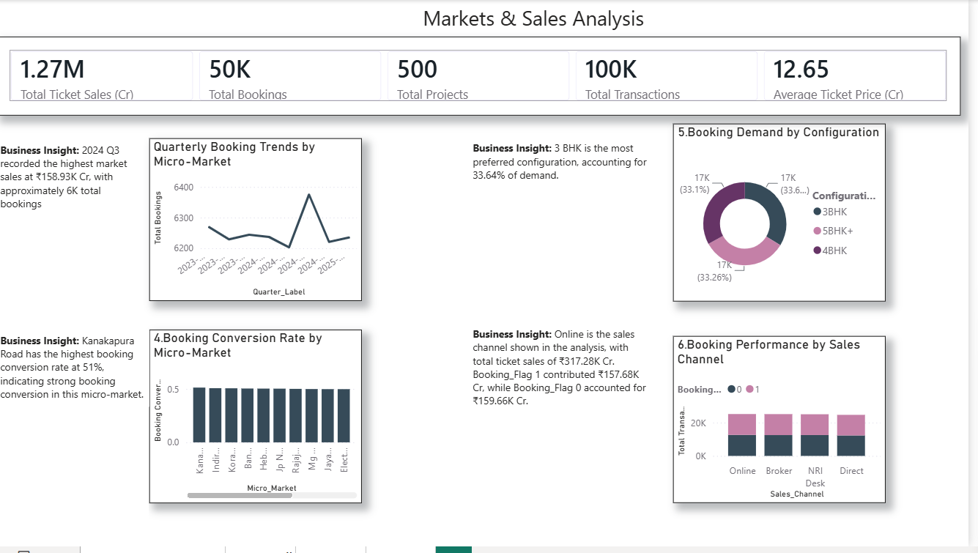
Figure 2: Power BI Dashboard – Page 2

Page 3 – Buyer & Sales Analysis
Analyzes buyer types, sales channels, and booking patterns.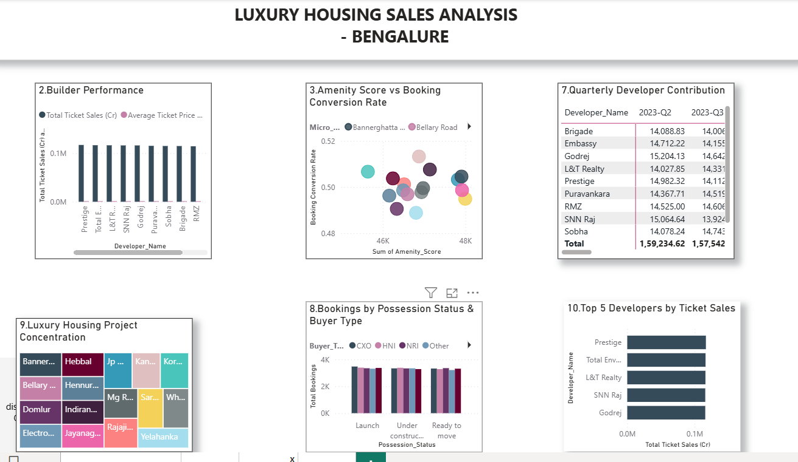
Figure 3: Power BI Dashboard – Page 3
Interactive Filters
Interactive filters allow users to select different categories and view the dashboard results based on their selection.
- Micro_Market
- Developer_Name
- Configuration
- Buyer_Type
- Purchase_Year
Power BI Analysis Questions
Ten business-focused questions were analyzed using Power BI.

- Which micro-market has the highest booking conversion rate?
- Which configuration has the highest demand?
- Which quarter has the highest market sales?
- Which sales channel generates the highest ticket sales?
- Which developer has the highest ticket sales?
- Which developer has the highest quarterly contribution?
- Which developer performs best overall?
- Which micro-market shows strong amenities and booking performance?
- Which possession stage has the highest bookings?
- Which micro-market has strong overall sales and transaction performance?
Business Insights
- Kanakapura Road has the highest booking conversion rate at 51%.
- 3 BHK is the most preferred configuration, accounting for 33.64% of total demand.
- 2024 Q3 recorded the highest market sales at ₹158.93K Cr, with approximately 6K bookings.
- The Online sales channel generated ₹317.28K Cr in total ticket sales.
- Prestige recorded the highest developer ticket sales at ₹1,16,750.20 Cr.
- Prestige recorded the highest quarterly contribution in 2024 Q3, at ₹15,194.57 Cr.
- Prestige was the top-performing developer with ₹1,16,750.20 Cr in ticket sales.
- Jayanagar recorded an amenity score of 47,919.87, 50% booking conversion, and ₹80.77K Cr ticket sales.
- Launch-stage properties recorded the highest bookings at 3,471, with CXO buyers associated with this result.
- Sarjapur Road recorded ₹50,081.82K Cr ticket sales, 500 projects, 3K bookings, 6K transactions, and an average ticket price of ₹12.84 Cr.
Recommendations
- Kanakapura Road → Focus more on this market.
- 3 BHK → Offer more 3 BHK properties.
- 2024 Q3 → Study what made sales high.
- Online Sales → Improve digital marketing.
- Prestige → Study its successful sales strategy.
- Prestige Q3 → Continue successful strategies.
- Prestige → Maintain its strong market position.
- Jayanagar → Focus more on this market.
- Launch Stage → Focus on launch-stage marketing.
- Sarjapur Road → Consider it for future projects
Tools & Technologies
Python | Pandas | NumPy | Power BI | DAX | CSV
Python – Data cleaning and feature engineering
Pandas – Data manipulation
NumPy – Numerical operations
Power BI – Dashboard and visualization
DAX – Data analysis and calculations
CSV – Final dataset storage
Conclusion
This project analyzed Bengaluru’s luxury housing sales data using Python and Power BI. The analysis identified important market trends, buyer preferences, developer performance, booking patterns, and high-performing micro-markets. The interactive Power BI dashboard helped convert the data into meaningful business insights that can support better real-estate sales and marketing decisions.
the Pipeline Visual
Somewhere in the methodology section, we'll have:
Raw Dataset
↓
Python Data Cleaning
↓
Feature Engineering
↓
Clean CSV
↓
Power BI
↓
DAX + KPIs
↓
Dashboard
↓
Business Insights
↓
Recommendations
Pipeline Summary
The project followed a structured data analysis pipeline. The raw dataset was first cleaned and prepared using Python. Feature engineering was then performed to create useful analytical fields. The cleaned dataset was stored as a CSV file and imported into Power BI. DAX was used to create KPIs and calculated measures. The results were presented through an interactive Power BI dashboard, which was used to identify business insights and develop recommendations.

